**DAILY ONLINE ACTIVITIES SUMMARY**

|  |  |  |  |  |  |  |  |  |
| --- | --- | --- | --- | --- | --- | --- | --- | --- |
| **Date:** | **1-06-2020** | | | | | **Name:** | **JAIDITHYA** | |
| **Sem & Sec** | **6th B section** | | | | | **USN:** | **4AL17CS118** | |
| **Online Test Summary** | | | | | | | | |
| **Subject** | | **CNSC** | | | | | | |
| **Max. Marks** | | **60** | | **Score** | | | **48** | |
| **Certification Course Summary** | | | | | | | | |
| **Course** | Introduction to Data Science [Start Course](https://courses.cognitiveclass.ai/courses/course-v1:CognitiveClass+DV0101EN+v1/jump_to/block-v1:CognitiveClass+DV0101EN+v1+type@course+block@course) | | | | | | | |
| **Certificate Provider** | | | **Cognitive class** | | **Duration** | | | **3hrs** |
| **Coding Challenges** | | | | | | | | |
| **Problem Statement:** 1. Python Program to remove duplicate elements from a list  2.Write a Java Program to left rotate the elements of an array | | | | | | | | |
| **Status: solved** | | | | | | | | |
| **Uploaded the report in Github** | | | | | **Yes** | | | |
| **If yes Repository name** | | | | | **Daily status-1st june** | | | |
| **Uploaded the report in slack** | | | | | **yes** | | | |

Online test report assessment screenshot

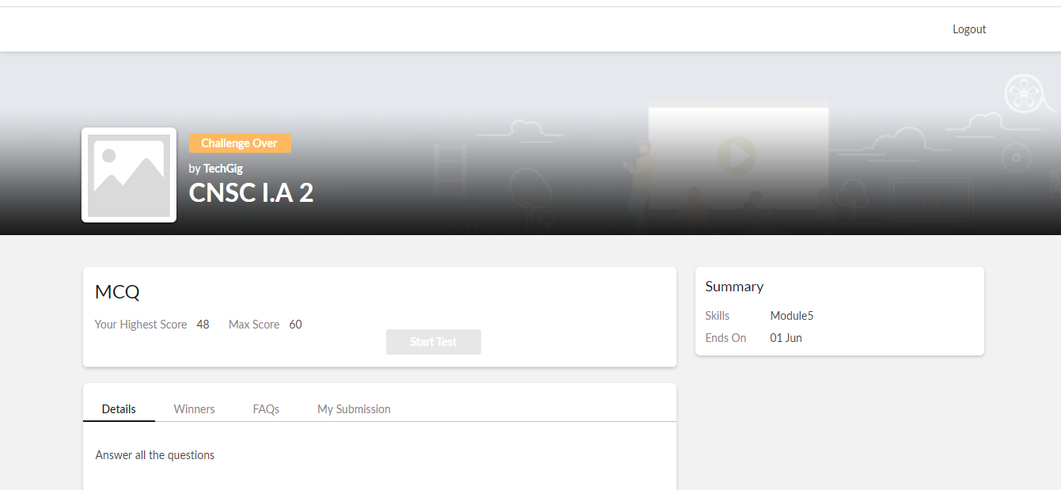

## Certification course details- Introduction to Data Science F:\12\certificate update\june1st\Screenshot (108).png

## F:\12\certificate update\june1st\Screenshot (107).pngF:\12\certificate update\june1st\Screenshot (105).pngF:\12\certificate update\june1st\Screenshot (106).png

Coding Challenges Details-

1.Python Program to remove duplicate elements from a list

2.Write a Java Program to left rotate the elements of an array

